****

**Project Report on**

**MIT-NOTEBLOCK**

### BY

|  |  |
| --- | --- |
| **17MCA019** | **Chirag Jain** |
| **17MCA034** | **Dhiresh Gullapalli** |
|  |  |

Under the guidance of

**Mr. Yusuf Patrawala**

**(Academic Year: 2018 – 2019)**

**IN PARTIAL FULFILLMENT OF**

**6005- Mini Project Using Android**

**As prescribed by MITWPU**

**Dr. Vishwanath Karad MIT-World Peace University’s**

**School of Management (PG)**

**Pune**

CERTIFICATE

This is to certify that Mr. Chirag Jain,17MCA019 of MIT-WPU’s School of Management (PG) have successfully completed the project report titled MIT-NOTEBLOCK in partial fulfilment of requirement for **Course Code and Course Name** asprescribed by the Dr. Vishwanath Karad **MIT-World Peace University**.

This Report is the record of authentic work carried out during the academic year 2018-19.

|  |  |  |
| --- | --- | --- |
| **Name of Guide**  Mr. Yusuf Patrawala | Prof. Dr. T. J. Vidyasagar  Head of School  MITWPU School of Management | Prof. Dr. Sayalee Gankar  Dean  MITWPU School of Management |

Date:

Place:

Examined by:

Examiner 1

Examiner 2

CERTIFICATE

This is to certify that Mr. Dhiresh Bharat Gullapalli of MIT-WPU’s School of Management (PG) have successfully completed the project report titled MIT-NOTEBLOCK in partial fulfilment of requirement for **Course Code and Course Name** asprescribed by the Dr. Vishwanath Karad **MIT-World Peace University**.

This Report is the record of authentic work carried out during the academic year 2018-19.

|  |  |  |
| --- | --- | --- |
| **Name of Guide**  Mr. Yusuf Patrawala | Prof. Dr. T. J. Vidyasagar  Head of School  MITWPU School of Management | Prof. Dr. Sayalee Gankar  Dean  MITWPU School of Management |

Date:

Place:

Examined by:

Examiner 1

Examiner 2

DECLARATION

We, Mr. Chirag Jain,17MCA019 & Mr. Dhiresh Bharat Gullapalli,17MCA034 hereby declare that this Research Report is the record of authentic work carried out by us during the academic year 2018-19 and has not been submitted to any other University or Institute towards the award of any degree.

|  |  |  |
| --- | --- | --- |
| **Roll No.** | **Name** | **Sign** |
| **17MCA019** | **Chirag Jain** |  |
| **17MCA034** | **Dhiresh Gullapalli** |  |
|  |  |  |
|  |  |  |
|  |  |  |
|  |  |  |
|  |  |  |
|  |  |  |
|  |  |  |
|  |  |  |

**Table of Contents**

| **Sr No.** | **Particulars** | **Page No.** |
| --- | --- | --- |
| **1** | **Introduction, Objective & Scope of the Project** |  |
| **2** | **Introduction to the Database/File used** |  |
| **3** | **User Interface Screens** |  |
| **4** | **Future Scope** |  |
| **5** | **Bibliography** |  |

**Introduction**

**MIT-Noteblock** is an Faculty-Student Notes Sharing Application, it is Integrated with Firebase Database which can be accessed globally and help in improving functionality of the Application. The Admin or Faculty can access the Web Application using credentials and Create Categories for the Notes, Later he can add Notes to the Particular Category which he selects and store it in the Database .The whole Application is developed into Two Modules

1. **Admin Panel(Faculty Panel)**
2. **User Panel (Student Panel)**
3. **Admin Panel**

This Module is an Web Application developed using Html,Css,JavaScript,JQuery .The Admin Panel helps to store the Data into the Firebase Database where the Data is Stored in form of Nodes and References are Created. It has two functionalities to create an Category and Second is to Upload Images or Notes in Form of “.PDF” or “.JPEG” to the Database.

1. **User Panel**

This Module is an Android Application developed using Java and Android. The user can view the Notes uploaded to the Firebase by Admin and can add them to favourites, user can also share and Download the Notes as per his choice. But before performing any functionalities user has to authenticate himself.

**Objective**

* To make an Feasible Application to help Faculty-Students to share Notes.
* Avoid Duplication of Notes
* Easily Accessible Anytime
* Download Feature to Store the File in Local Directory
* Share Feature to Share Notes
* Easy UI to avoid Ambiguity
* Favourite Option to Bifurcate Notes
* Authentication to track user activity and provide Security
* Firebase Database helps to access data Globally

**Scope of the Project**

* An UI which is User Friendly for Faculty and Students.
* Authentication to authenticate Users.
* Global Database to Access Files
* Web Application to Upload Files
* Android Application to Fetch the Files
* Use of New Technologies to Make the Application Reliable

**Introduction to Database Used**

**FIREBASE**



Firebase evolved from Envolve, a prior startup founded by James Tamplin and Andrew Lee in 2011. Envolve provided developers an API that enables the integration of online chat functionality into their websites. Firebase's first product was the Firebase Realtime Database, an API that synchronizes application data across iOS, Android, and Web devices, and stores it on Firebase's cloud. The product assists software developers in building real-time, collaborative applications.

**Firebase Hosting**

Firebase Hosting is a static and dynamic [web hosting service](https://en.wikipedia.org/wiki/Web_hosting_service) that launched on May 13, 2014. It supports hosting static files such as [CSS](https://en.wikipedia.org/wiki/Cascading_Style_Sheets), [HTML](https://en.wikipedia.org/wiki/HTML), [JavaScript](https://en.wikipedia.org/wiki/JavaScript) and other files, as well as support through Cloud Functions. The company states that Firebase Hosting grew out of customer requests; developers were using Firebase for its real-time database but needed a place to host their content

**Firebase Storage**

Firebase Storage provides secure file uploads and downloads for Firebase apps, regardless of network quality. The developer can use it to store images, audio, video, or other user-generated content. Firebase Storage is backed by [Google Cloud Storage](https://en.wikipedia.org/wiki/Google_Cloud_Storage)

### Realtime Database

The Firebase Realtime Database is a cloud-hosted NoSQL database that lets you store and sync between your users in realtime.The Realtime Database is really just one big JSON object that the developers can manage in realtime.

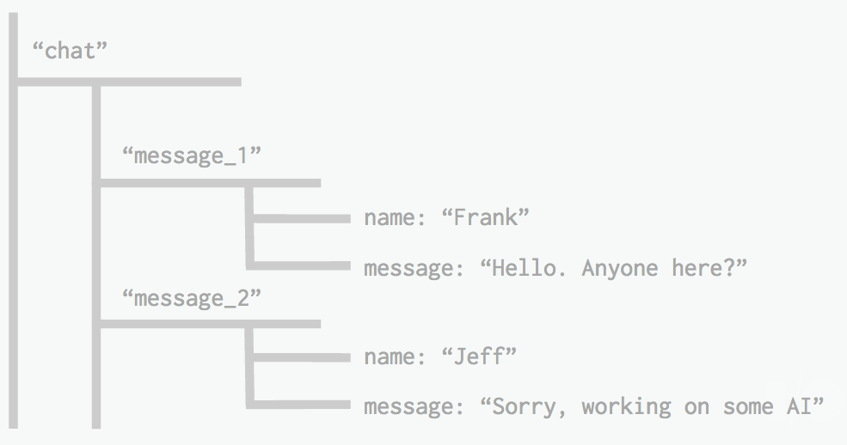

Realtime Database => A Tree of Values

With just a single API, the Firebase database provides your app with both the current value of the data and any updates to that data.Realtime syncing makes it easy for your users to access their data from any device, be it web or mobile. Realtime Database also helps your users collaborate with one another.The Realtime Database can also integrate with Firebase Authentication to provide a simple and intuitive authentication process.

### Authentication

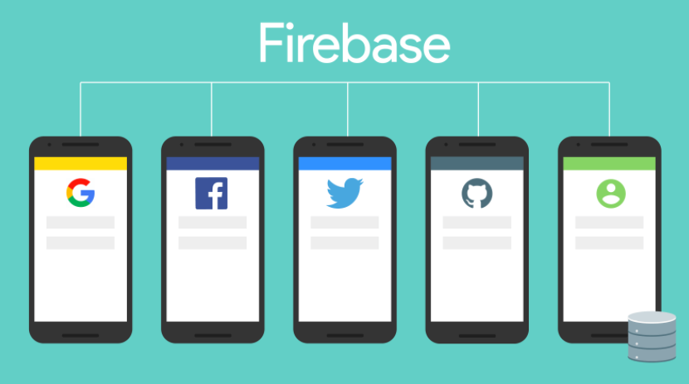

Firebase Authentication provides backend services, easy-to-use SDKs, and ready-made UI libraries to authenticate users to your app.You can authenticate your app’s users through the following methods:

* Email & Password
* Phone numbers
* Google
* Facebook
* Twitter
* & more!

Using Firebase Authentication makes building secure authentication systems easier, while also improving the sign-in and on boarding experience for end users. Firebase Authentication is built by the same people who created Google Sign-in, Smart Lock, and Chrome Password Manager.

**UI SCREENS**

**ADMIN PANEL**

**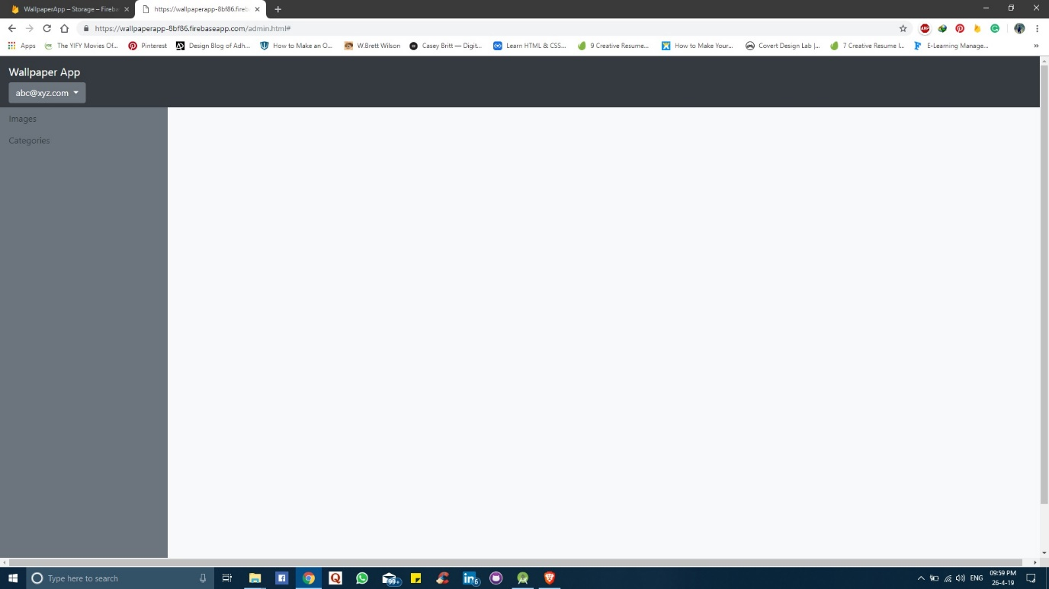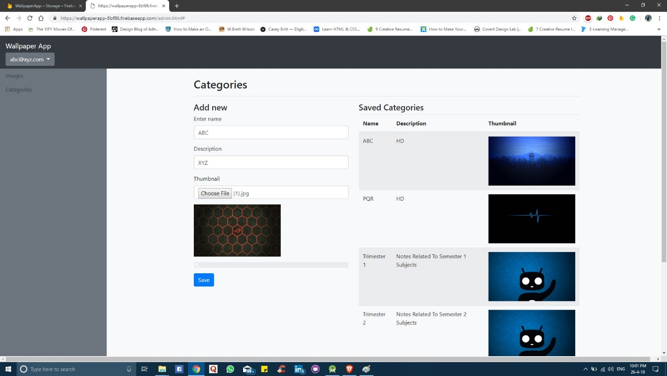**

**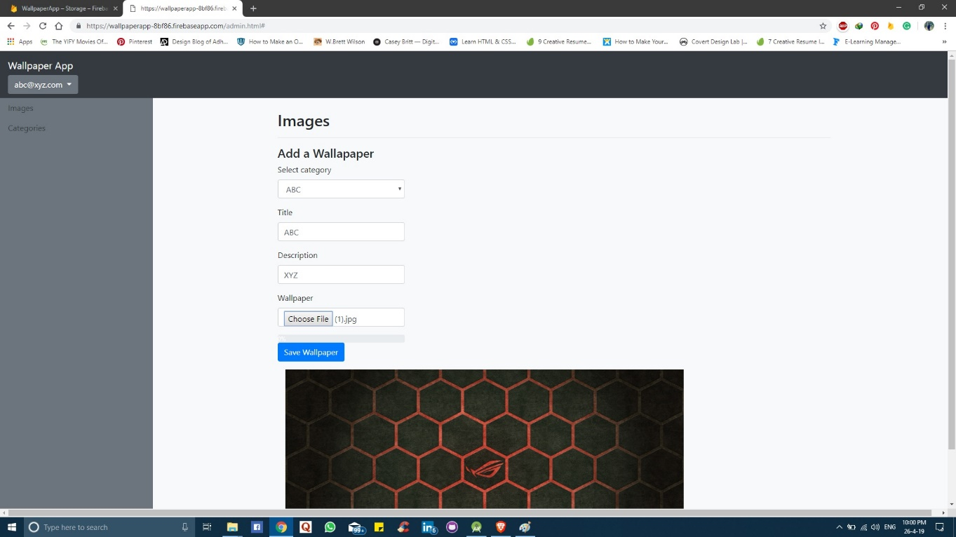**

**USER PANEL**

|  |  |
| --- | --- |
| **C:\Users\dhire\AppData\Local\Microsoft\Windows\INetCache\Content.Word\Screenshot_2019-04-26-22-21-50-705_com.example.mitnoteblock.png** | **C:\Users\dhire\AppData\Local\Microsoft\Windows\INetCache\Content.Word\Screenshot_2019-04-26-22-21-56-955_com.example.mitnoteblock.png** |
| **C:\Users\dhire\AppData\Local\Microsoft\Windows\INetCache\Content.Word\Screenshot_2019-04-26-22-22-09-209_com.example.mitnoteblock.png** | **C:\Users\dhire\AppData\Local\Microsoft\Windows\INetCache\Content.Word\Screenshot_2019-04-26-22-22-16-474_com.example.mitnoteblock.png** |
| **C:\Users\dhire\AppData\Local\Microsoft\Windows\INetCache\Content.Word\Screenshot_2019-04-26-22-22-02-524_com.example.mitnoteblock.png** | **C:\Users\dhire\AppData\Local\Microsoft\Windows\INetCache\Content.Word\Screenshot_2019-04-26-22-21-59-739_com.example.mitnoteblock.png** |
|  |  |

**FUTURE SCOPE**

* Improved UI
* Chat Integration with Faculty for Doubts
* Comment Section
* Edit Suggest Option for Notes
* Support of Different File Format
* Publishing Application in Play Store

**BIBLIOGRAPHY**

* [**https://firebase.google.com/docs/?authuser=0**](https://firebase.google.com/docs/?authuser=0)
* [**https://stackoverflow.com/**](https://stackoverflow.com/)
* [**https://www.simplifiedcoding.net/**](https://www.simplifiedcoding.net/)
* [**https://www.youtube.com/watch?v=tAN244LVW-s&list=PLk7v1Z2rk4hgNu5zXbGctiCWYebxjdeey**](https://www.youtube.com/watch?v=tAN244LVW-s&list=PLk7v1Z2rk4hgNu5zXbGctiCWYebxjdeey)
* [**https://www.android.com/**](https://www.android.com/)
* [**https://www.codeproject.com/**](https://www.codeproject.com/)
* [**https://www.w3schools.com/**](https://www.w3schools.com/)